# WorkItem: 9948 'Recent Exceptions' window in OpenPDC Manager:

1. **Aim**

To implement the ‘Recent Exception List’ in OpenPDC manager as per request seen in Issue Tracker list in OpenPDC open source site.

1. **Description** (As in the Issue Tracker list in <http://openpdc.codeplex.com/>)

It would be useful to have a window that showed a list of the recent exception. Right now, we have everything in the ErrorLog, but in previous versions we had this information available directly from the manager.

1. **Solution:**

The solution is to provide a UI in OpenPDCManager to view all recent exceptions.

All exceptions obtained in ErrorLogger in TVA.core is first caught and saved to a new table ‘ExceptionLog’ in the DB. The new Menu item ‘Exception Log’ in ‘Manage’ Menu will list all recent exception caught. A maximum of 2000 records will be available in the newly added table for exception. After this maximum limit, older records will be overwritten.

This Exception Log will contain all the exceptions generated by any OpenPDCManager that is configured to this DB. The default refresh rate for Exception log is 10 seconds.

Sample screen shots are shown below;

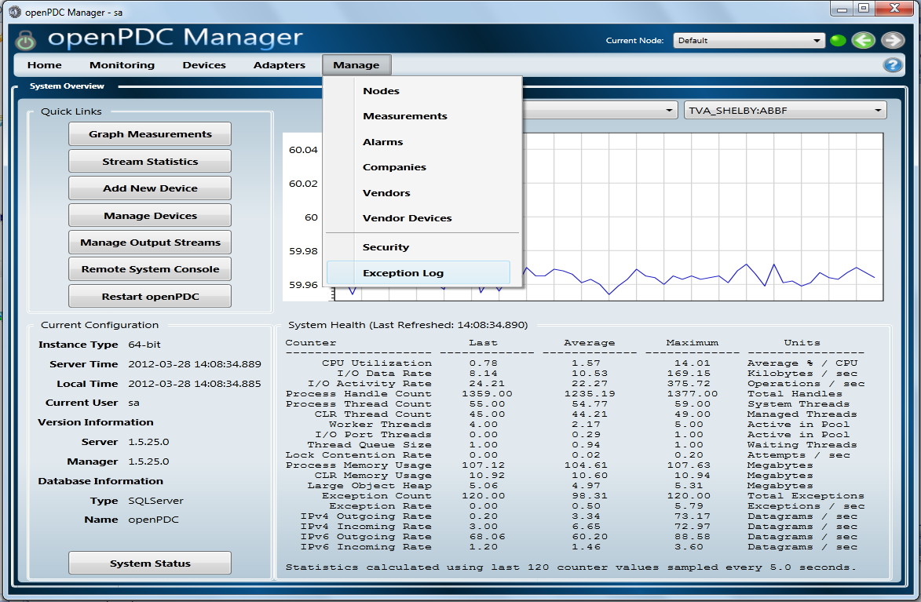

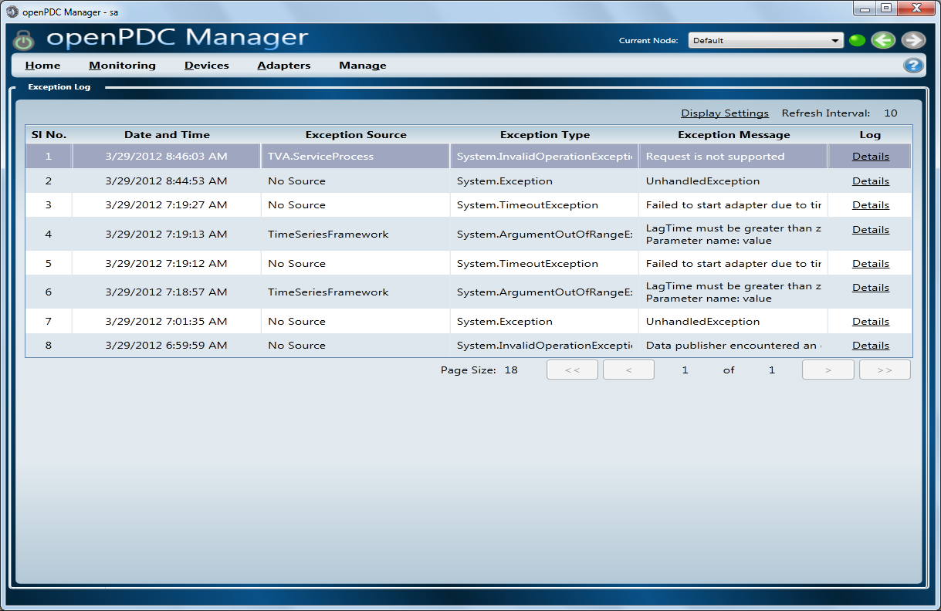

The exception Log viewer’s displays the following details on each exception;

|  |  |  |
| --- | --- | --- |
| Sl No. | Column Name | Description |
| 1 | Sl No. | Serial Number of exceptions in the order in which they are generated or entered into backend database. |
| 2 | Date and Time | Time at which the exception info loaded into backend database. |
| 3 | Exception Source | This will show the source of outer exception and not inner exceptions. |
| 4 | Exception Type | Type of generated exception such as system.invalid operation etc. This will be the type of the outermost exception and not of any inner exceptions. |
| 5 | Exception Message | Cause of the exception generated such as Unhandled Exception etc. This will be the message value of the outermost exception and not of any inner exceptions. |
| 6 | Log | This field contains a link button. On clicking this button a window will pop up and which will show the detailed explanation of currently selected exception. These details include information about all inner exceptions, time, system info, application info, stack trace. |

1. **Files related to Bug fix:**
2. **New files added for the fix**

# Synchrophasor in OpenPDCManager

### ExceptionLogUserControl.xaml

Xaml file for the new user control for exception viewer. Follows ‘PagedViewModelBase’ style.

### ExceptionLogUserControl.xaml.cs

Class Name: ExceptionLogUserControl

Inherited from: UserControl

Namespace: openPDC.UI.UserControls

This is the C# file developed, corresponding to ExceptionLogUserControl.xaml file. This class file contains methods for user control developed for logging recent exceptions. Contains methods for Exception Viewer items sorting, configure refresh interval for Exception Viewer etc

### ExceptionLogViewModel.cs

Class Name: ExceptionLogViewModel

Inherited from: PagedViewModelBase<ExceptionLog, int>

Namespace: openPDC.UI.ViewModels

This defines the page view model class for exception viewer user control. Contains methods and properties for updating the data source of exception viewer, and configure refresh interval.

### ExceptionMonitor.cs

Class Name: ExceptionMonitor

Inherited from: IDisposable

Namespace: openPDC.UI

This provides a monitoring class for keeping the exception viewer updated with recent exceptions. Contains methods and properties for setting the refresh interval, (re)fetch recent exception details from backend data base on configured refresh interval.

### ExceptionLog.cs

Class Name: ExceptionLog

Inherited from: DataModelBase

Namespace: openPDC.UI.DataModels

This represents a light-weight exception info class for loading a particular exception into exception viewer. This class contains properties/methods for meeting specific requirements of exception viewer.

### LogDisplay.cs

ClassName: LogDisplay

Inherited from: window

Namespace: openPDC.UI.Modal

This window shows currently selected exception’s overall details including machine info, time, user info, inner exception details etc

### LogDisplay.xaml

Xaml file for Logdisplay.

1. **Files updated for fix:**

# TVA.core in TVACodeLibrary

Class Name: ErrorLogger

Namespace: TVA.ErrorManagement

New functions Added

1. LogError

Inserts recent exception info into ExceptionLog table in backend database, which will be invoked by ErrorLogger.Log() method. ErrorLogger.Log() will be called for logging recent exceptions.

1. RestoreLogSize

Deletes old records from ExceptionLog table before inserting new rows into table so as keeping the table size limit to 2000 rows. This method will be invoked by ErrorLogger. LogError() method.

Functions Modified

1. Log

Modified this function to include call to ErrorLogger.LogError() for logging encountered exception details into backend data base for analyzing at openPDC Manager.

# Synchrophasor in OpenPDCManager

Modified Files

### Menu.xml

Added Menu Item for Exception Viewer which will load user control ‘openPDC.UI.UserControls.ExceptionLogUserControl’.

1. **DB Script updation:**

A new table ‘Exception Log’ is added to OpenPDC’s DB creation scripts. This table contains the attributes Sl: No, Date and time, Exception source, Exception type, Exception Message and Details.

The related script files for the following DB has been updated for the fix;

Oracle, MySQL, SQL Server and SQLite.

1. **Lines of codes updated as part of the fix:**

Tvacodelibrary : 51 LOC in .cs file

Synchrophaser : 617 in. cs and. xaml

1. **TFS Code check In Locations:**

Currently, we got access permission to Project OpenPDC (TFS07) only.

But we need permission to TVACodeLibrary(TFS05) also, to check in the TVACodeLibrary.

A screen shot of the TFS location to which we have permission right now is shown below;

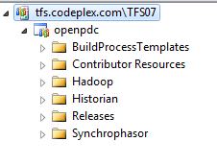

1. **Known issues**

The following are some of the existing issues that were found while implementing this;

1. OpenPDCManager crashes when a value such as 0 or a negative number is given as Refresh interval in alarm. After this situation, the crash occurs whenever the Alarm Menu is clicked .This is handled in Exception log viewer’s refresh interval.
2. Refresh interval value for alarms entered in seconds is not converted to milliseconds in code areas related to Alarm. This is handled in Exception Log viewer’s refresh interval
3. For each back button a new instance is created, resulting in the rising of memory usage. This is an issue that needs major change.